**DAILY ONLINE ACTIVITIES SUMMARY**

|  |  |  |  |  |  |  |  |
| --- | --- | --- | --- | --- | --- | --- | --- |
| **Date:** | **04/06/2020** | | | | **Name:** | **Sheetal** | |
| **Sem & Sec** | **8 B** | | | | **USN:** | **4AL16CS091** | |
| **Online Test Summary** | | | | | | | |
| **Subject** | | **SMS** | | | | | |
| **Max. Marks** | | **60** | | **Score** | | **60** | |
| **Certification Course Summary(Internship)** | | | | | | | |
| **Task** | **Study-Learning data analytics concepts with platform specified**  **POC- working on sathya sales dataset dashboard development and Testing for the POC done** | | | | | | |
| **Company** | | | **Gain Insights** | **Duration** | | | **9 hr** |
| **Coding Challenges** | | | | | | | |
| **Problem Statement:**  **1)Program to find HCF of two numbers** | | | | | | | |
| **Status:completed** | | | | | | | |
| **Uploaded the report in Github** | | | | **Yes** | | | |
| **If yes Repository name** | | | | [alvas-education-foundation](https://github.com/alvas-education-foundation)/ **[sheetal-shettigar](https://github.com/alvas-education-foundation/sheetal-shettigar)** | | | |
| **Uploaded the report in slack** | | | | **Yes** | | | |

ONLINE TEST

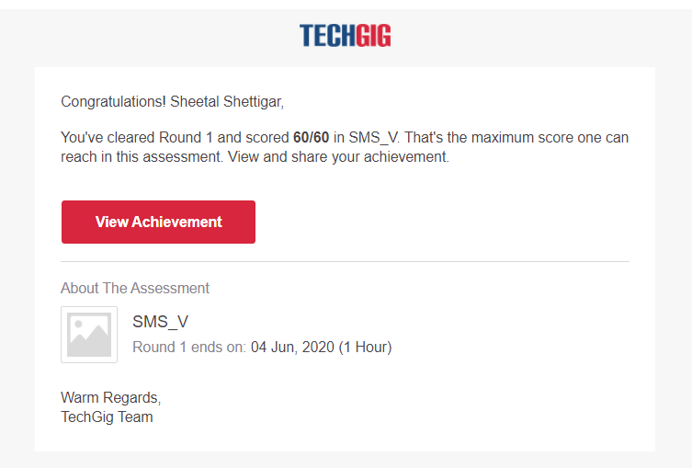

CODING CHALLENGE:

PROGRAM 1 :

defcompute_hcf(x,y):

if x>y:

smaller=y

else:

smaller=x

for i in range(1,smaller+1):

if((x%i==0)and(y%i==0)):

hcf=i

return hcf

num1=54

num2=24

print("The H.C.F.is",compute_hcf(num1,num2))